Embedded Controller Win 7 Win 10 Upgrade Information Sheet

Contact Name: Company:
Contact Phone: E-mail:
Job/Facility: # of Controllers to Upgrade:
*Note: IED1100/1200 or 32-bit Series controllers cannot be updated to Windows 10
If your license is EXPIRED, please contact your sales associate first as this will speed up the process.
Info we need will also include the VBK file (data backup), LFX file (license) and the GCB file (messages backup) or c:/message folder zipped. Contact: licensing@atlasied.com or your salesperson for any questions, all three files are needed to begin.

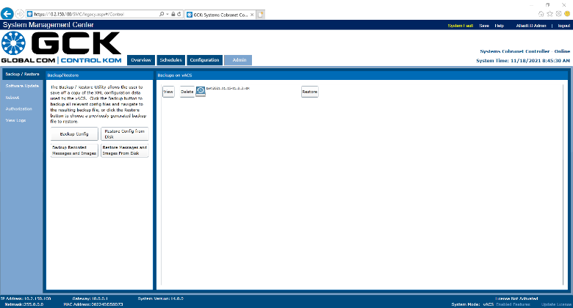 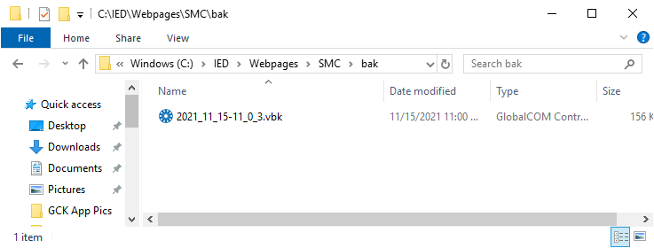 VBK/GCB
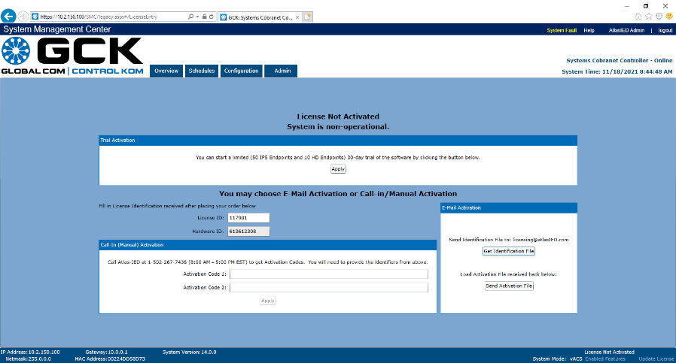 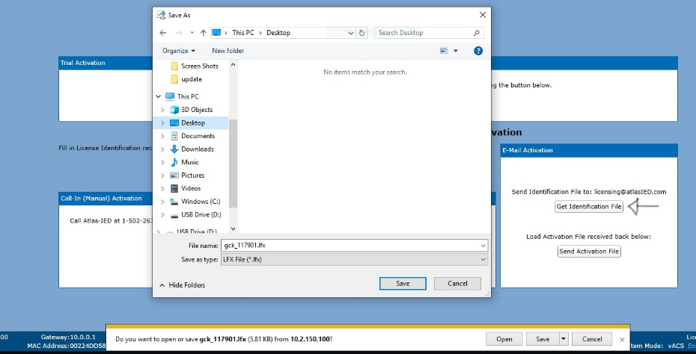 LFX
1/2
Information | Controller #1 | Controller #2 | Controller #3 | Controller #4 | Controller #5
IP Address:
HW Type | □ IP108  □ IP116  □Cobranet  □Dante | □ IP108  □ IP116  □Cobranet  □Dante | □ IP108  □ IP116  □Cobranet  □Dante | □ IP108  □ IP116  □Cobranet  □Dante | □ IP108  □ IP116  □Cobranet  □Dante
Primary or Lifeline? | □ Pri □ LLne | □ Pri □ LLne | □ Pri □ LLne | □ Pri □ LLne | □ Pri □ LLne
Serial #:
GCK License Expiration Date
# HD Endpoints
# IP Endpoints
SAFE Feature Installed? | □ Yes □ No | □ Yes □ No | □ Yes □ No | □ Yes □ No | □ Yes □ No
FAS Message Library Installed? | □ Yes □ No | □ Yes □ No | □ Yes □ No | □ Yes □ No | □ Yes □ No
FAS Language(s)
Ambient Noise/EQ being Used? *if YES Send C:IED/services/vACS/Ambient Folder | □ Yes □ No | □ Yes □ No | □ Yes □ No | □ Yes □ No | □ Yes □ No
Visual Paging Used? | □ Yes □ No | □ Yes □ No | □ Yes □ No | □ Yes □ No | □ Yes □ No
TTS Engine Installed | □ No  □ Nuance  □ ReadSpeak  Other: | □ No  □ Nuance  □ ReadSpeak  Other: | □ No  □ Nuance  □ ReadSpeak  Other: | □ No  □ Nuance  □ ReadSpeak  Other: | □ No  □ Nuance  □ ReadSpeak  Other:
TTS Languages (list per cont.)
Remote Access Available? | □ Yes □ No | □ Yes □ No | □ Yes □ No | □ Yes □ No | □ Yes □ No

Please provide any additional notes that you think may be helpful to this process:

https://www.atlasied.com/transportation-resources/article/instructions-for-hd-replacement for installation instructions. See win10 bootup issues for recovery screen at start up. 2/2

